Eagle 7.2.0

EAGLE 7.2.0 (Easily Applicable Graphical Layout Editor) is a flexible and expandable EDA schematic capture, PCB layout, autorouter and CAM program. EAGLE is popular among hobbyists because of its freeware license and rich availability of component libraries on the web.It is very easy to learn PCB design in Eagle Software.Printed Circuit Boards, also known as PCBs, are the foundation of any hardware-based product. Before EDA software, Engineers usually designed electronics circuitry and integrated circuits by hand or some other manual process.There are various PCB design Software available in the market.some are for student version and some are for commercial purpose.

It could be a daunting task choosing from several tens of software in the market. When selecting a design package to use, it is always advisable to use some of the latest tools with available support and community. In the EDA industry, some of the best and most popular tools are mostly not free. Nevertheless, there are still a couple of powerful free ones. In this article, I will highlight some of the best free PCB design software you can find for designing your printed circuit board layout, and hopefully, this list will help you to pick what works for you.

Eagle is arguably one of the most well know schematics and PCB design software. Formerly known as Cadsoft Eagle, but now called Autodesk Eagle after its purchase from Autodesk. Autodesk EAGLE contains a schematic editor, for designing circuit diagrams and a PCB layout editor for designing PCBs. It provides component placement, PCB routing, a comprehensive library content, a thriving community, and many more.

Eagle is available for Windows, Linux, and Mac.You can create gerbers easily through eagle software.

You can download the Eagle 7.2.0 crack from the official website of Autodesk Eagle. for instance shown in below image.

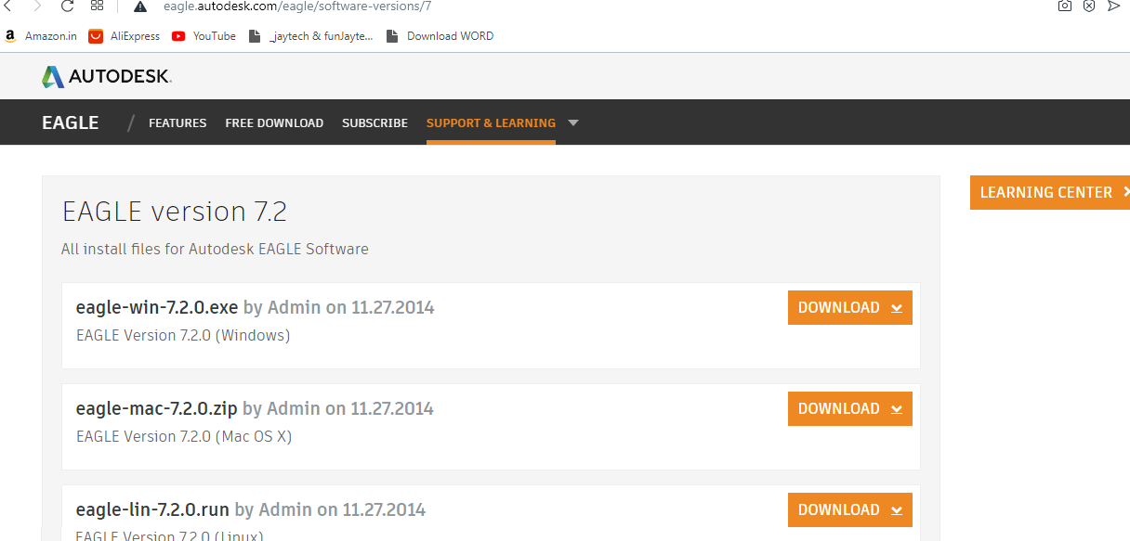

After downloading and installation of software.

HOW TO START ??

First make your Schemetic and then switch to PCB design.You can take help from Eagle example PCB design available in the software.

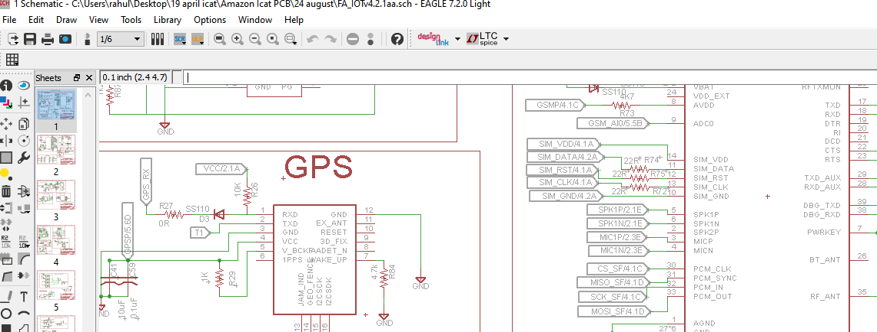

TOP ASSEMBLY:

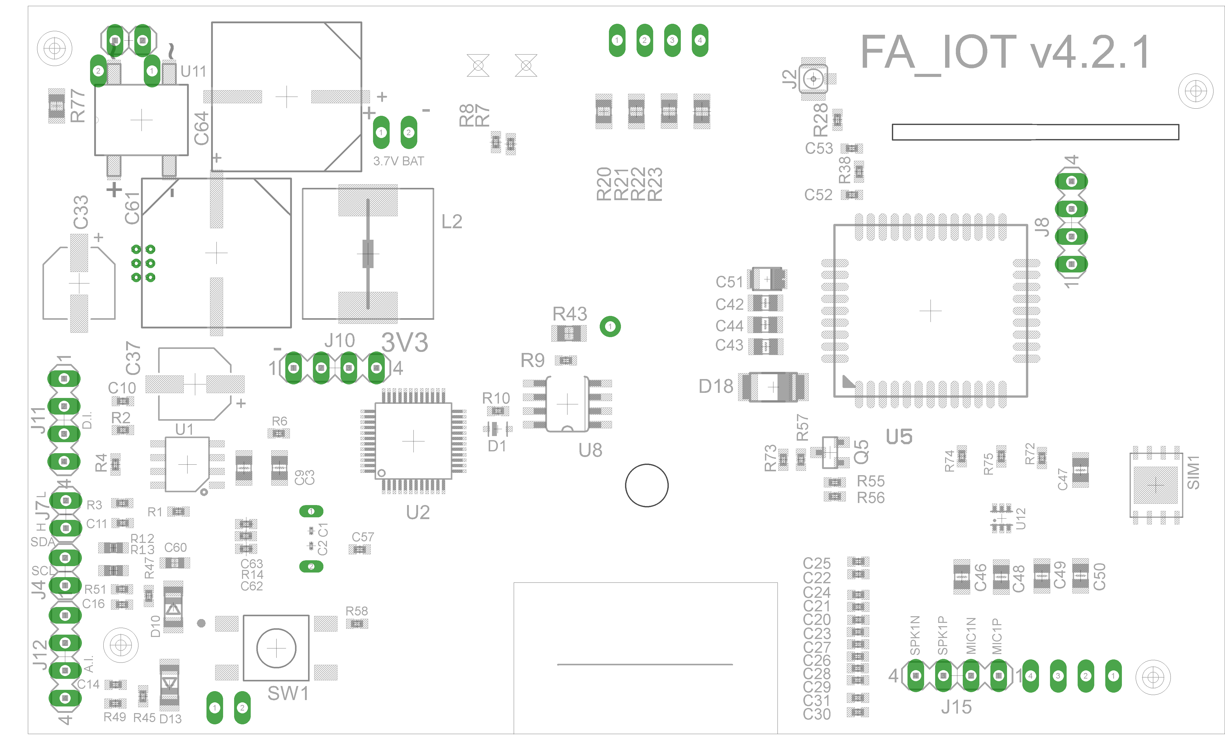

BOTTOM ASSEMBLY:

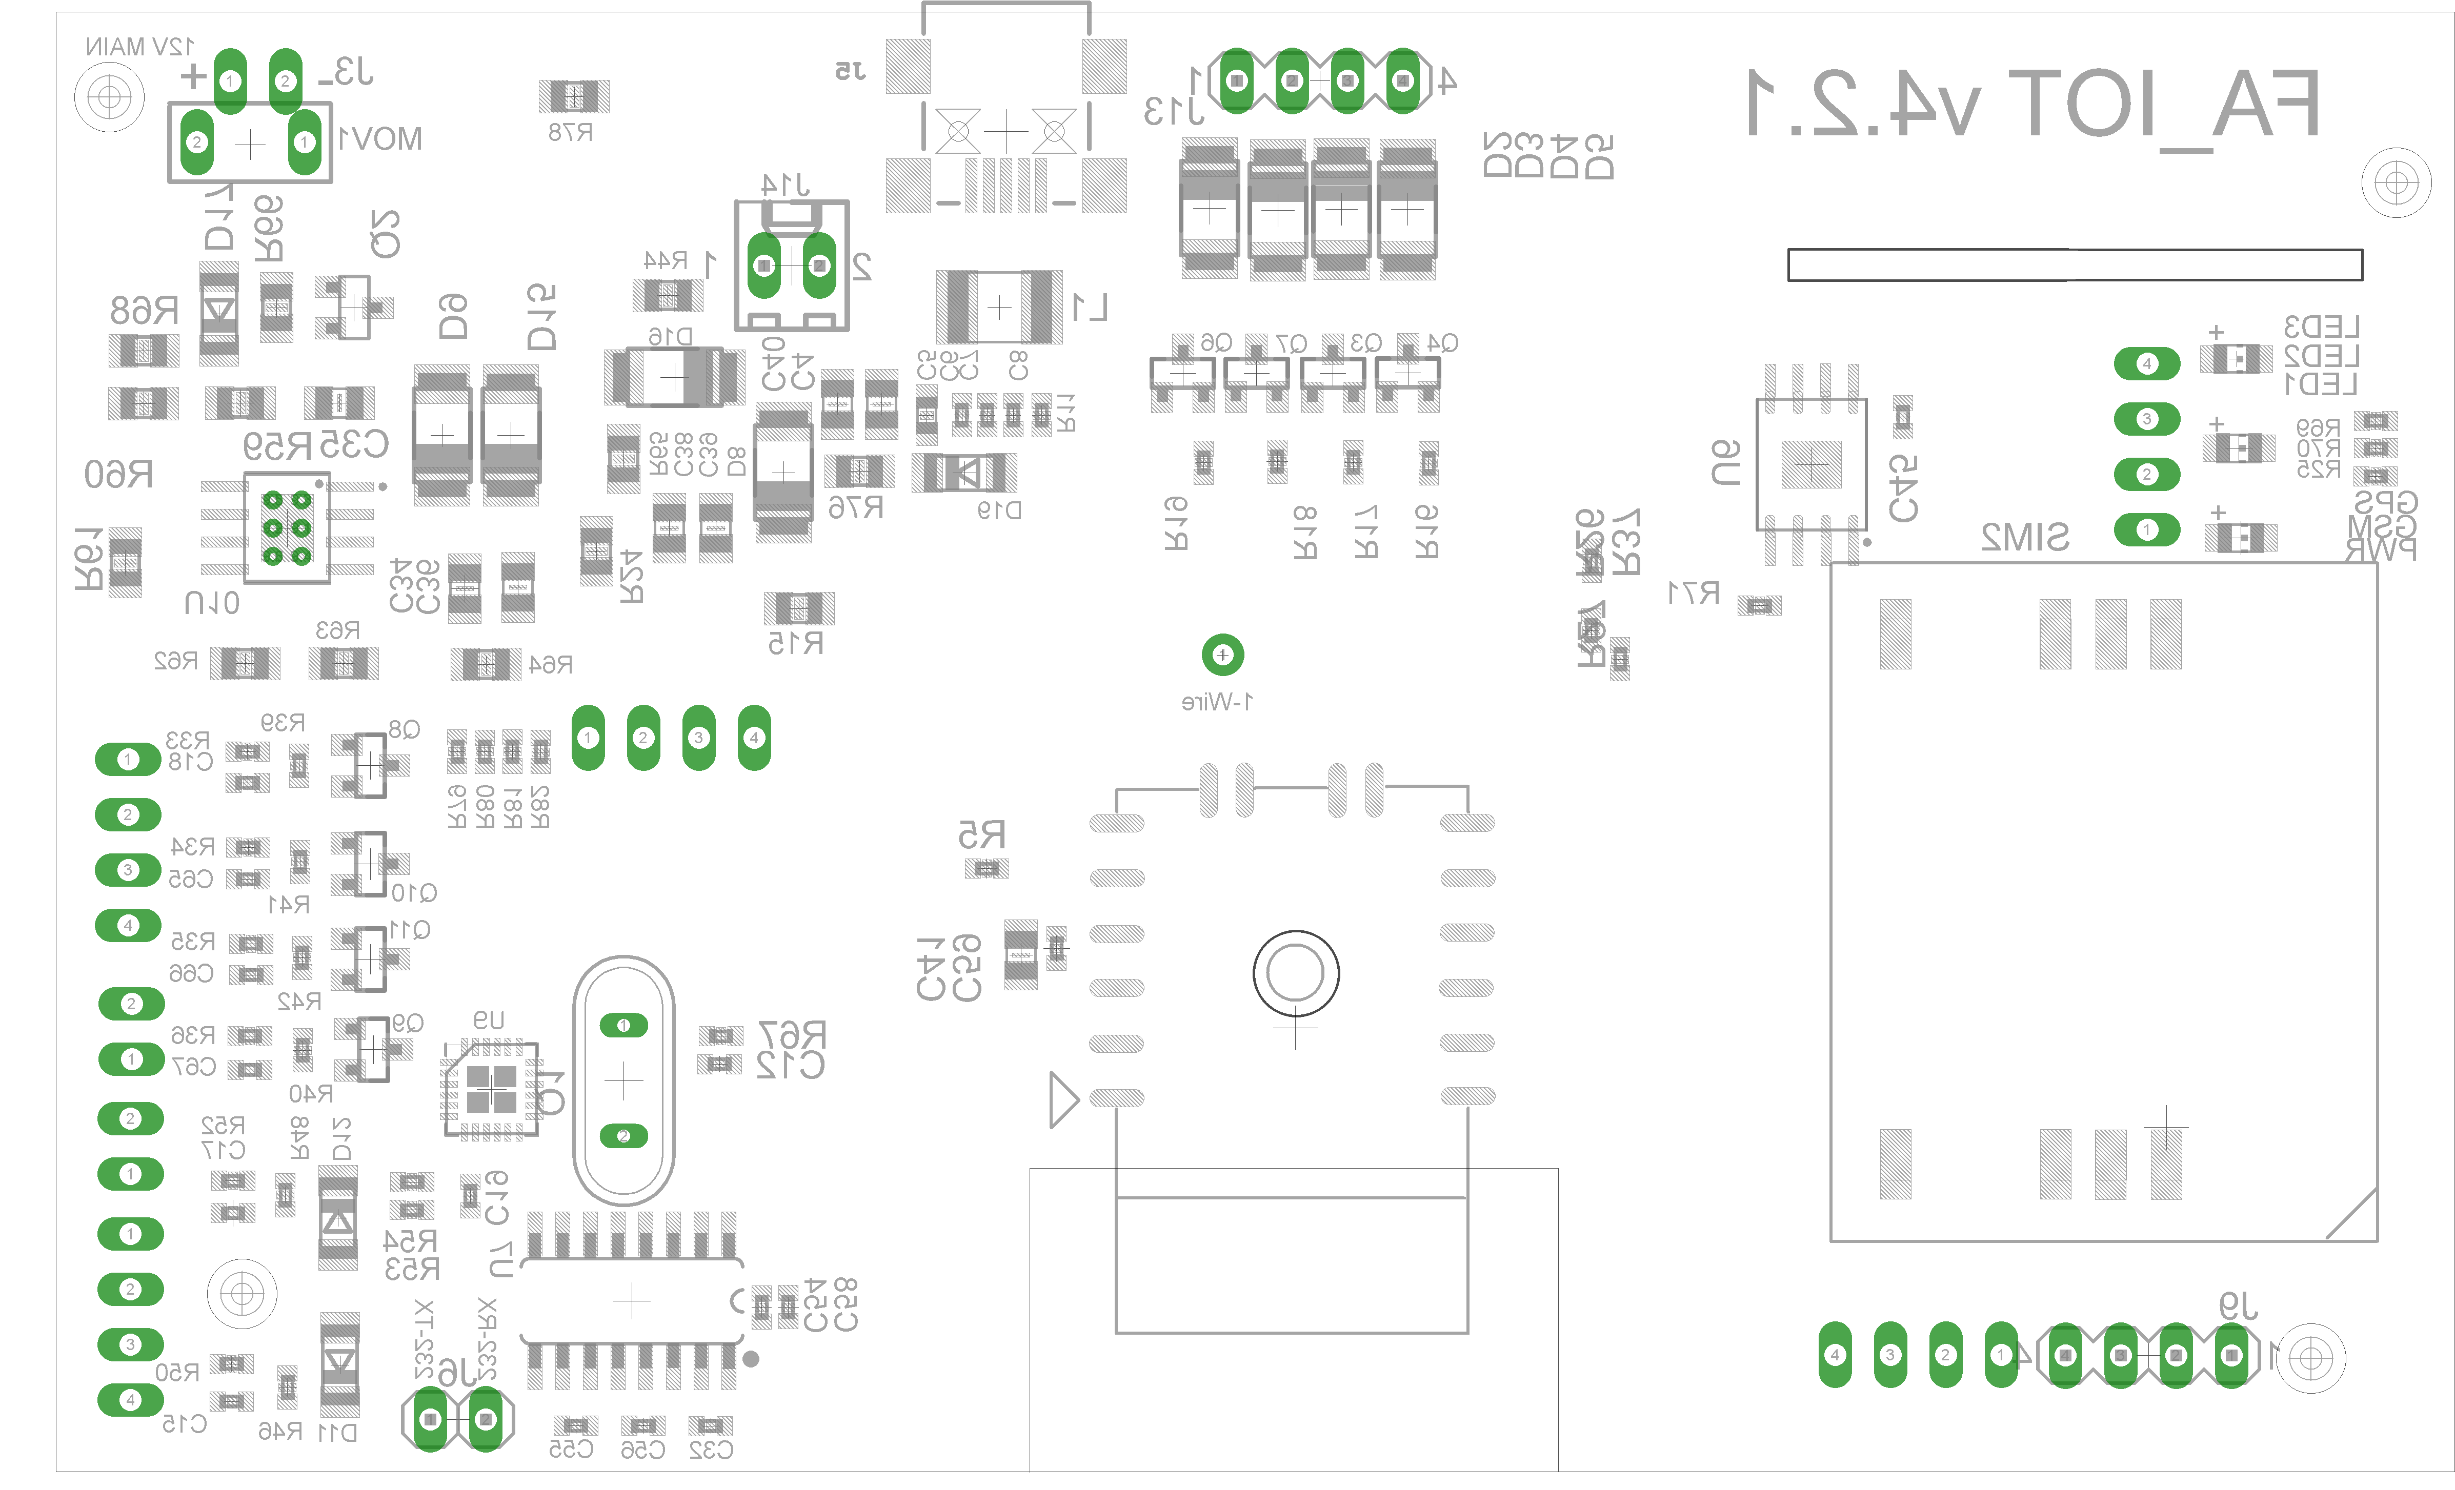

TOP SIDE:

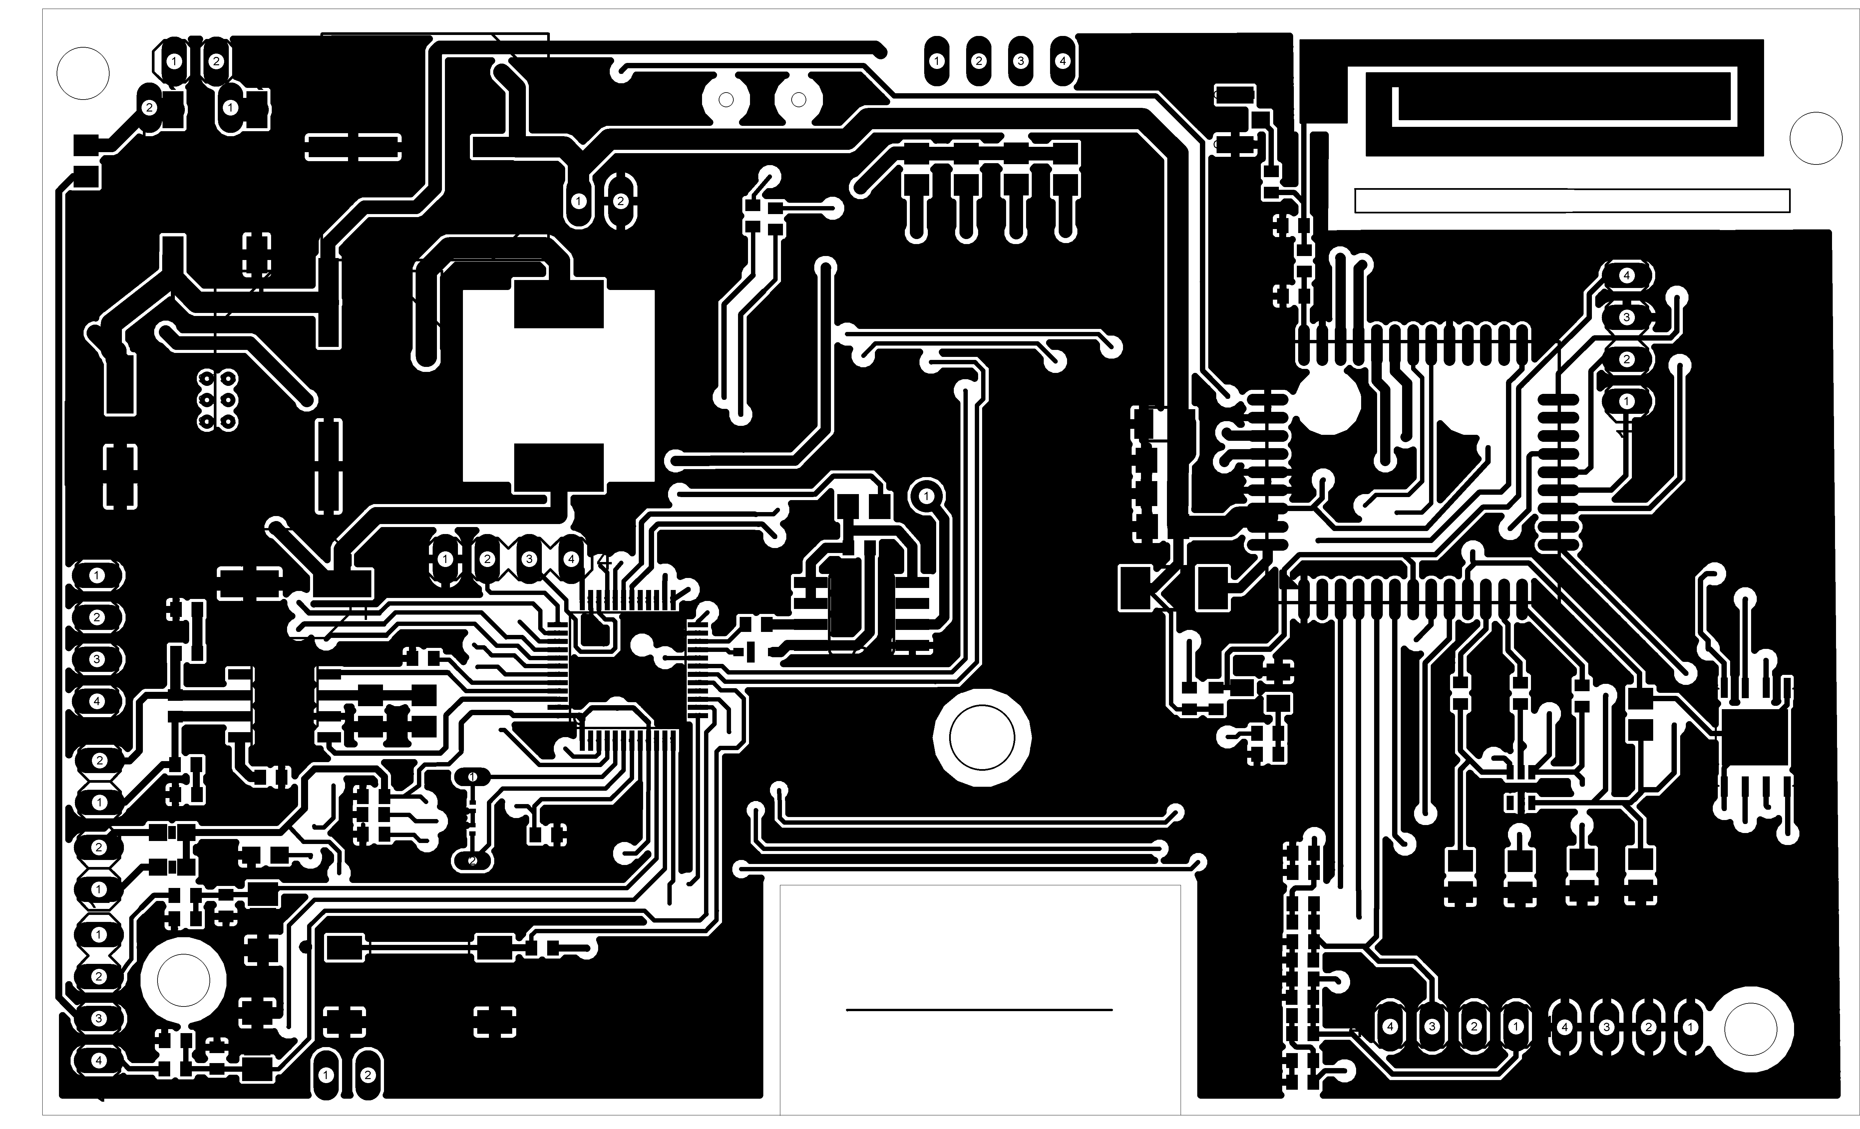

BOTTOM SIDE:

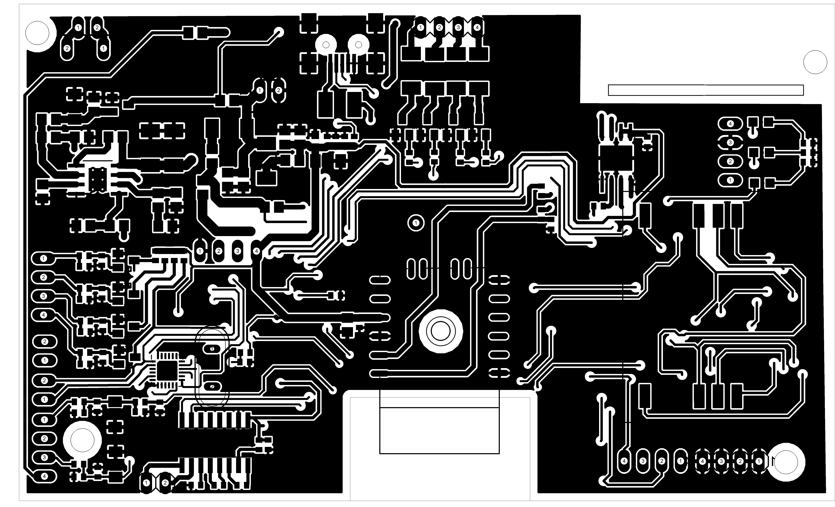

After the PCB design. Create your gerber file and send it to the Fabrication House.There are varoius PCB fabricators in the market. The one I choose is PCB Power.their quality is good and cost effective. They are really well for the sample PCBs.

Precautions to be take care while PCB design:

Design Rules define all the parameters that the board layout has to follow.
The Design Rule Check checks the board against these rules and reports any violations.

The Design Rules of a board can be modified through the Design Rules dialog, which appears if the DRC command is selected without a terminating ';'.

Newly created boards take their design rules from the file 'default.dru', which is searched for in the first directory listed in the "Options/Directories/Design rules" path. If no such file is present, the program's builtin default values apply.

Note regarding the values for Clearance and Distance: since the internal resolution of the coordinates is 1/10000mm, the DRC can only reliably report errors that are larger than 1/10000mm.

File Tab:

The File tab shows a description of the current set of Design Rules and allows you to change that description (this is strongly recommended if you define your own Design Rules). There are also buttons to load a different set of Design Rules from a disk file and to save the current Design Rules to disk.
Note that the Design Rules are stored within the board file, so they will be in effect if the board file is sent to a board house for production. The "Load..." and "Save as..." buttons are merely for copying a board's Design Rules to and from disk.

The Layers tab defines which signal layers the board actually uses, how thick the copper and isolation layers are, and what kinds of vias can be placed (note that this applies only to actual vias; so even if no via from layer 1 to 16 has been defined in the layer setup, pads will always be allowed).

The Clearance tab defines the various minimum clearance values between objects in signal layers. These are usually absolute minimum values that are defined by the production process used and should be obtained from your board manufacturer.
The actual minimum clearance between objects that belong to different signals will also be influenced by the net classes the two signals belong to.

The Distance tab defines the minimum distance between objects in signal layers and the board dimensions, as well as that between any two drill holes. Note that only signals that are actually connected to at least one pad or smd are checked against the board dimensions. This allows edge markers to be drawn in the signal layer without generating DRC errors.

The Sizes tab defines the minimum width of any objects in signal layers and the minimum drill diameter. These are usually absolute minimum values that are defined by the production process used and should be obtained from your board manufacturer.
The actual minimum width of signal wires and drill diameter of vias will also be influenced by the Net Class the signal belongs to.

The Restring tab defines the width of the copper ring that has to remain after the pad or via has been drilled. Values are defined in percent of the drill diameter and there can be an absolute minimum and maximum limit. Restrings for pads can be different for the top, bottom and inner layers, while for vias they can be different for the outer and inner layers.
If the actual diameter of a pad (as defined in the library) or a via would result in a larger restring, that value will be used in the outer layers. Pads in library packages can have their diameter set to 0, so that the restring will be derived entirely from the drill diameter.

The Masks tab defines the dimensions of solder stop and cream masks. They are given in percent of the smaller dimension of smds, pads and vias and can have an absolute minimum and maximum value.
Solder stop masks are generated for smds, pads and those vias that have a drill diameter that exceeds the given Limit parameter.
Cream masks are generated for smds only.

In the example design, we’ve been working on we left our design rules at their default. But as you dive into more professional projects you’ll likely set up some custom design rules before you ever place a component or lay down a track. Until that time arrives, let’s walk through how to run a basic Design Rule Check on our project.

- Open your PCB layout (.brd) file from your Autodesk EAGLE Control Panel.
- Select the DRC drc-icon tool on the left-hand side of your interface to open the DRC Setup dialog.

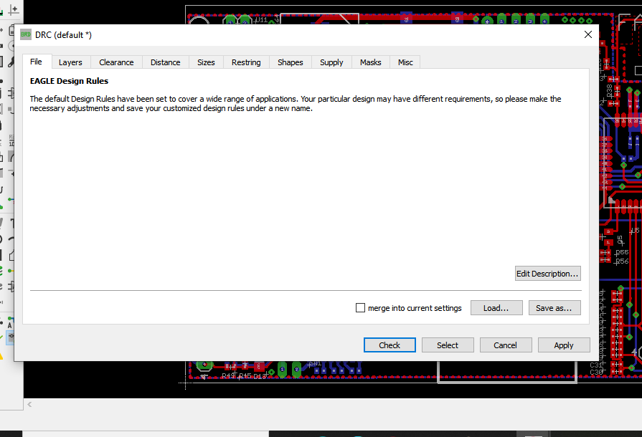

- Take a minute to check out the default rules set here in all of the available tabs. When you’re done, select the Check button to run your Design Rule Check.
- If you have any issues to address, the DRC Errors dialog will open as shown below. And if there aren’t any errors, then you’ll see DRC: No errors in the bottom-left corner of your interface.

It’s the time to make the firmware for the device. we first start to program the microcontroller.STM32F103c8t6 is the microcontroller of STM32 family.IT is very easy to program.you only need basic C programming knowledge.

STM32CubeMX:

STM32CubeMX is a graphical tool that allows a very easy configuration of STM32 microcontrollers and microprocessors, as well as the generation of the corresponding initialization C code for the Arm® Cortex®-M core or a partial Linux® Device Tree for Arm® Cortex®-A core), through a step-by-step process. stm32cubemx imageThe first step consists in selecting either: an STMicrolectronics STM32 microcontroller, micropocessor or a development platform, which matches the required set of peripherals, or an example running on a specific development platform.

STM32Cube MCU & MPU Packages are part and the STM32Cube initiative.They offer for each STM32 MCUs and MPUs series all the required embedded software bricks to operate the available set of peripherals, including :

STM32Cube MCU and MPU Packages for each individual STM32 MCU and MPUs series that include:
The hardware abstraction layer (HAL) enabling portability between different STM32 devices via standardized API calls
Low-layer (LL) APIs, a light-weight, optimized, expert oriented set of APIs designed for both performance and runtime efficiency
A collection of middleware components including RTOS, USB library, file system, TCP/IP stack, touch-sensing library or graphics library (depending on the STM32 series)
RF stacks such as Bluetooth® LE 5.2, OpenThread, Zigbee 3.0, LoRaWAN® and Sigfox, specific to every STM32 wireless series
For STM32 MPUs only, the BSP drivers are based on HAL drivers and provide an API Set to the evaluation board and 3rd party components.

Keil µVision:

The µVision IDE combines project management, run-time environment, build facilities, source code editing, and program debugging in a single powerful environment. µVision is easy-to-use and accelerates your embedded software development. µVision supports multiple screens and allows you to create individual window layouts anywhere on the visual surface.

The µVision Debugger provides a single environment in which you may test, verify, and optimize your application code. The debugger includes traditional features like simple and complex breakpoints, watch windows, and execution control and provides full visibility to device peripherals.

Quick Links
µVision Debugger
µVision User's Guide
Online manuals for MDK
Verification Tools
µVision Project Manager and Run-Time Environment
With the µVision Project Manager and Run-Time Environment you create software application using pre-build software components and device support from Software Packs. The software components contain libraries, source modules, configuration files, source code templates, and documentation. Software components can be generic to support a wide range of devices and applications.

You can download the Keil from the official website. You only required to download the MDK-Arm version as shown in the image below.

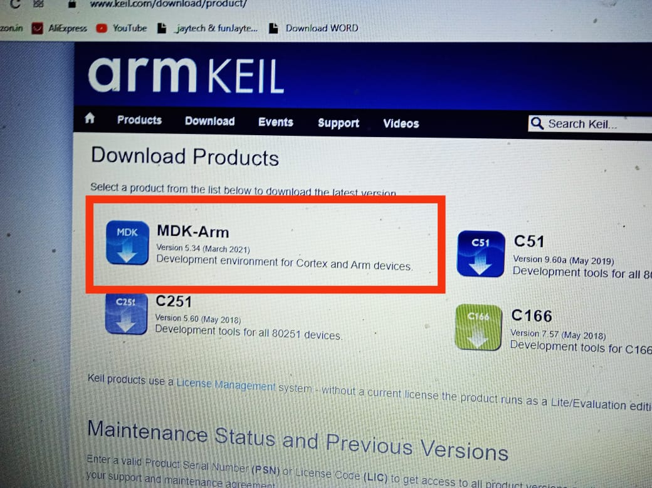

Now the controller part is done.It’s time to program GSM module M66.
Go to the quectel website and download the M66_opencpu-SDK.



OpenCPU is an embedded development solution for M2M field. Based on it, customers can
conveniently design embedded applications. It enables customers to create innovative
applications and download it directly into Quectel modules to run. In the OpenCPU solution,
GSM/GPRS module acts as a main processor. So, GSM/GPRS module with OpenCPU
solution facilitates customers’ product design and accelerates the application development.
M66-OpenCPU Module is a powerful functional quad-band GSM/GPRS module in LCC castellation packaging, featuring
embedded GNSS function. It has an ultra-compact profile of 18.7×16.0×2.1mm. In addition to Internet, telephony, SMS,
FOTA, and data storage functions, it builds in advanced audio player, recorder, QuecLocator, eCall, navigation system and
the new featured “Bluetooth” function, which make this module a best choice for applications that have strict requirements on
extended functions and cost-effectiveness.
OpenCPU module can be widely used in M2M field, such as tracker & tracing, automobile, energy, wearable devices, etc.

GCC Compiler Support
➢ MC60-OpenCPU supports free-of-charge GCC compiler (Sourcery CodeBench Lite for ARM EABI). The previous OpenCPU solution uses ARM RVCT as the compiler.
■
IDE Support
MC60-OpenCPU recommends two sets of tools to manage codes and compile program. One is command-line + Source Insight, and the other is Eclipse.

Components Used in VTS(Vehicle Tracking System)

- N32 GPS module
- M66 GSM Module
- STM32F103C8T6
- MPS4559 (power DC-DC step Down)
- MPU6050
- STC4054
- LDK220M33R
- E-Sim
- MAX3232
- DF10S(Bridge Rectifier)
- MOV
- TVS Diode
- ST Link utility
- Uart to TTL
- W25Q32FV(memory IC)

N32 GPS Module:

N32 is GNSS module with built-in LNA and Patch Antenna(18.0*18.0*2.0 mm+15.0*15.0*2.0mm), don’t need an extra antenna and external LNA. N32 can track as low as -160dBm signal level. The N32 has excellent low power consumption characteristic (acquisition 36mA, tracking 34mA).N32 supports various location and navigation applications, including autonomous GPS/GLONASS/IRNSS/ Galileo/QZSS/SBAS.

N32 module not only supports automatic antenna switching function, which can achieve switching between external active antenna and internal patch antenna, but also supports external active antenna detection and short protection. The detection and notification of different external active antenna status will be shown in the NMEA message including external active antenna connection, open circuit for antenna and antenna short-circuited. So host can query the external active antenna status timely and conveniently.

Key Features

⦁ GNSS receiver, supports GPS/Galileo/Glonass/IRNSS/QZSS/SBAS

⦁ 40 tracking/96 acquisition-channel, up to 136 PRN channels

⦁ Small footprint: 16.0x 16.0 x 2.25mm, 12-pin LCC package

⦁ Patch dimensions: 18.0*18.0*2.0 mm+15.0*15.0*2.0mm

⦁ Smart Jammer detection and suppression

⦁ Maximum NMEA update rate up to 20 Hz

⦁ Pulse-per-second (PPS) GNSS time reference

⦁ Adjustable duty cycle

⦁ typical accuracy: ±25ns

Operating temperature: -40 ~ +85ºC

⦁ Accuracy 2.5m CEP@-130dBm

⦁ RoHS compliant

The module provides complete signal processing from antenna input to host port in NMEA messages. The module requires 3.0V~3.6V (TYP: 3.3V) power supply. The host port is configurable to UART. Host data and I/O signal levels are 3.3V CMOS compatible.

⦁ N32 Functional Diagram

The following figure shows a functional diagram of the N32 and illustrates the mainly functional parts:

⦁ The GNSS chip

⦁ SAW filter

⦁ LNA

⦁ Patch Antenna interface

⦁ The communication interface

⦁ The control signals

⦁ Automatic antenna switching function

⦁ Support short circuit protection and antenna detection circuit for active antenna.

Power Input :

The power supply range of N32 is from 3.0V to 3.63V. The power supply should be able to provide sufficient current up to 100mA.The power supply range of V_BCKP is from 1.62V to 3.63V, typical 3.0V. Suggest customer keep the V_BCKP supply active all the time, the module will perform a quick start every time it is power-on.

PIN DIAGRAM :

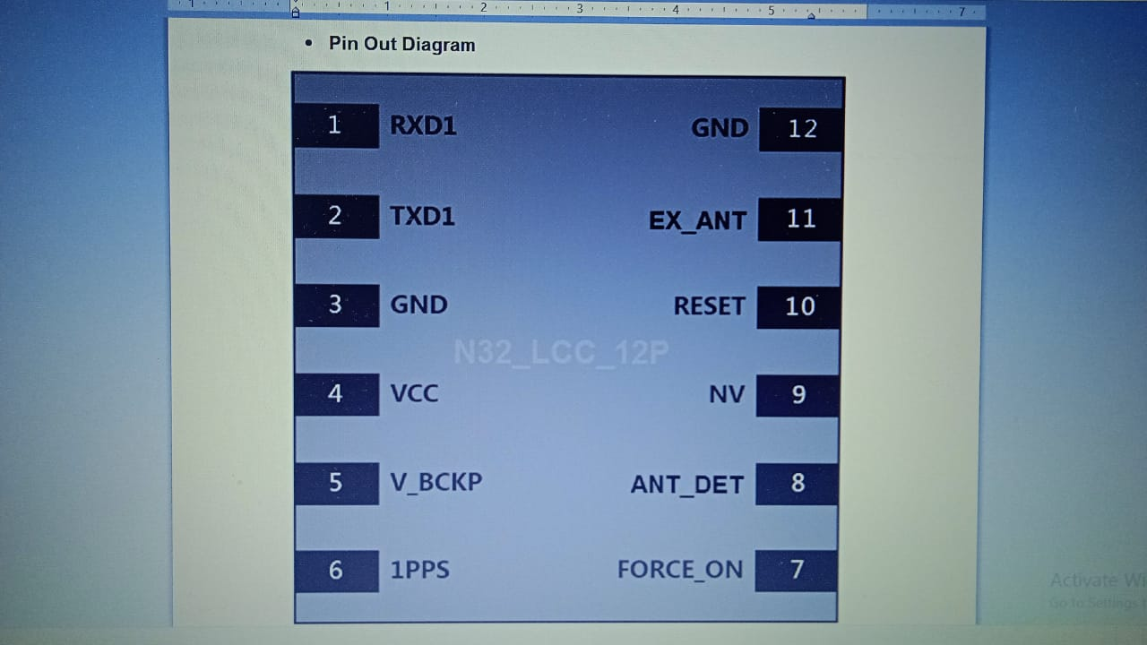

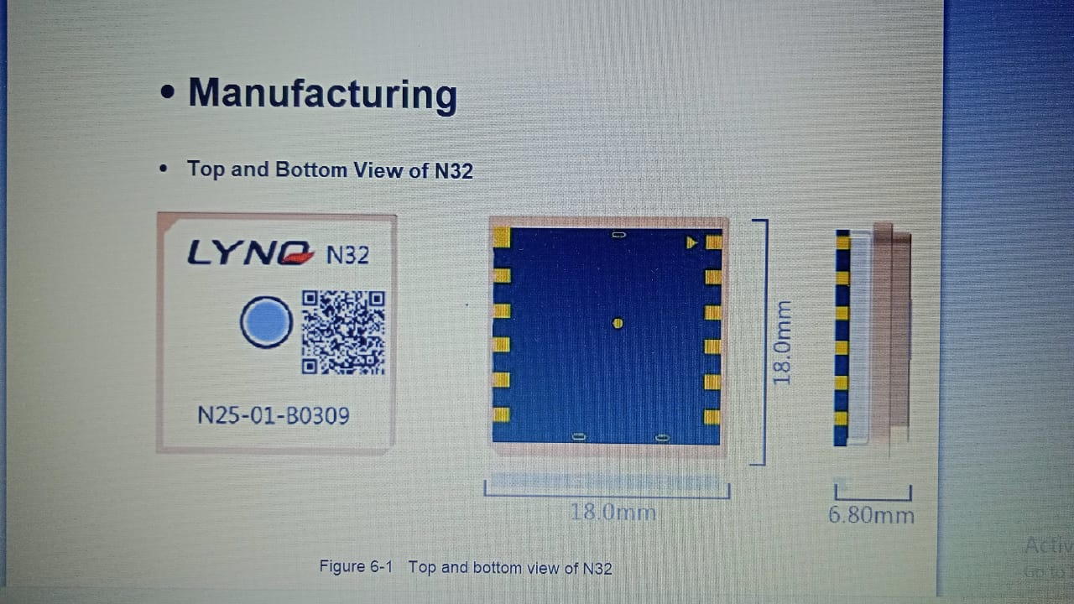

Reference Design :

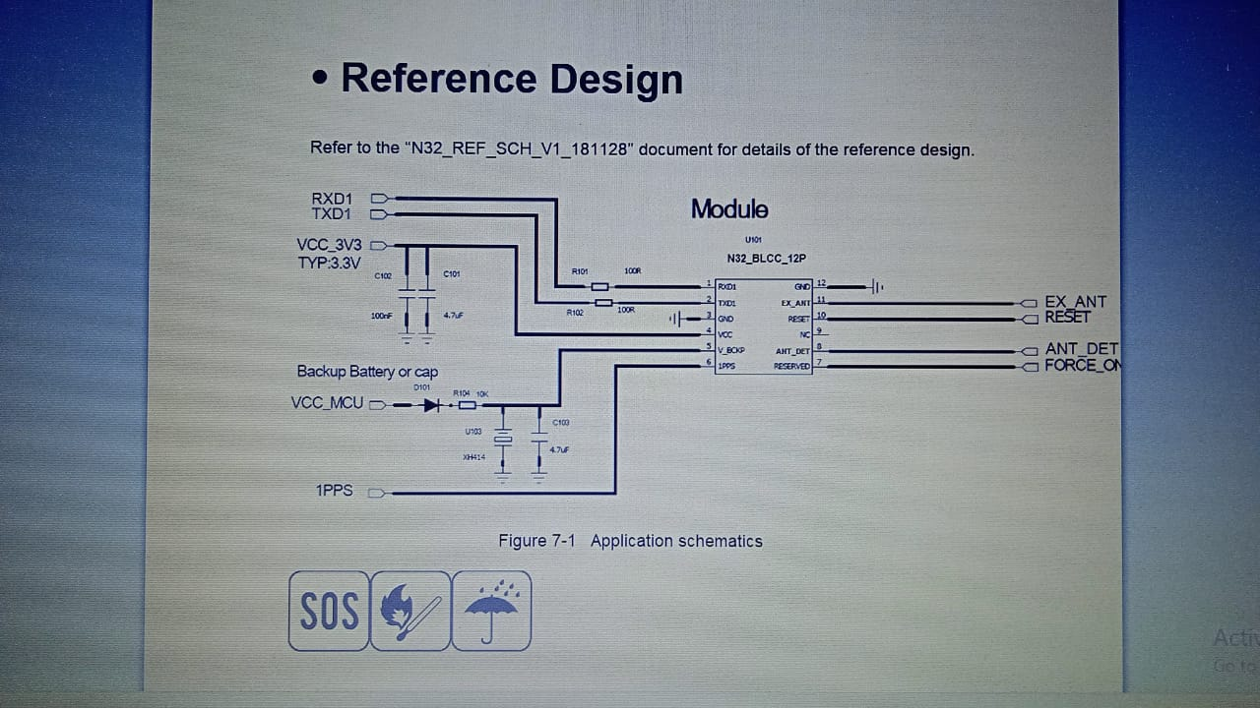

M66 GSM Module:

The M66 is a quad-band GSM/GPRS 2G module measuring 17.7mm × 15.8mm × 2.3mm which uses LCC castellation packaging. Based on the latest 2G chipset, it is optimized for data, SMS and audio transmission, and is designed for low-power IoT use cases that operate in harsh conditions.

The M66 uses surface mounted technology, making it ideal for large-scale manufacturing, which can have strict requirements on cost and efficiency. The M66’s ultra-compact profile makes it particularly suited to size-sensitive applications, and the module can serve a range of applications such as wearable devices, automotive, PDAs, asset tracking, POS, smart metering and telematics.

Key Features :

Supports frequency bands 850/900/1800/1900MHz
Easier soldering process with LCC package
Power consumption as low as 1.3mA
GPRS Multi-slot Class 12
Supports BT 3.0
Supports QuecFOTA
Supports Quectel OpenCPU
Embedded internet service protocols, multiple sockets and IP addresses

GSM/GPRS M66

Quad-band GSM/GPRS module
17.7mm × 15.8mm × 2.3mm
1.3g
Max. data rate: 85.6Kbps
SMT form factor
LCC castellation packaging
Extended temperature range of -40°C to +85°C

M66 is an ultra-small quad-band GSM/GRPS module using LCC castellation packaging on the market. Based on the latest 2G
chipset, it has the optimal performance in SMS & Data transmission and audio service even in harsh environment. The ultracompact 15.8mm × 17.7mm × 2.3mm profile makes it a perfect platform for size sensitive applications.
M66 adopts surface mount technology, making it an ideal solution for durable and rugged designs. The low profile and small
size of LCC package makes sure M66 can be easily embedded into size-constrained applications, and provides reliable
connectivity with applications. This kind of package is ideally suited for large-scale manufacturing which has strict requirements for cost and efficiency.
The compact form factor, low power consumption and extended temperature make M66 a best choice for M2M applications
such as wearable devices, automotive, industrial PDA, personal tracking, wireless POS, smart metering, telematics, and more.

